Name: _______________________________________________________ Date: ___/___/___

1. Graph the inequality .

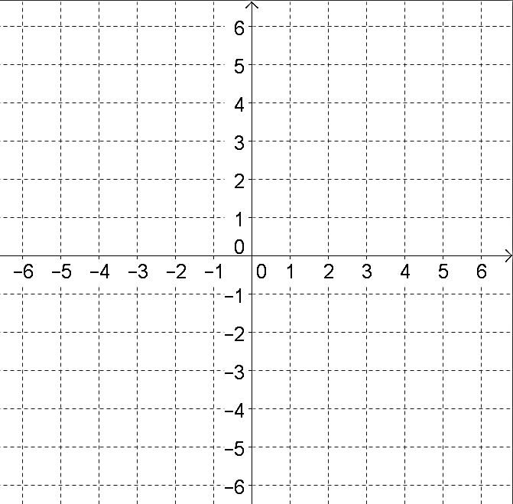

1. Which of the following graphs represents the inequality ?

|  |  |  |  |  |
| --- | --- | --- | --- | --- |
| A. |  |  | C. |  |
|  |  |  |  |  |
| B. |  |  | D. |  |

1. Which of the following represents the solution set to the system of inequalities? 

|  |  |  |  |  |
| --- | --- | --- | --- | --- |
| A. |  | C. |  |  |
| B. |  | D. |  |  |

1. Select all of the ordered pairs that are in the solution set of the system of inequalities given. 

A. (–3, 1) D. (–7, 4)

B. (0, –3) E. (1, 1)

C. (3, 3) F. (4, –2)

1. Graph the system of inequalities: 

