Name: _______________________________________________________ Date: ___/___/___
- Larry recorded the cost of enrollment and weekly tuition at summer camps in his state. He wrote a linear equation to estimate the total cost, based upon the number of weeks spent at camp and the cost of enrollment: y = 58x + 123. Identify the slope and y-intercept for this equation, and interpret the meaning of each in the context of the information presented.
Slope:
y-intercept:

- Gina charges an hourly rate plus a one-time setup fee for each home she decorates. The linear equation below can be used to determine the total she charges each customer.
y = 75x + 250
Identify the slope and intercept for the equation above and interpret the meaning of each in the context of the information presented.

Slope:
y-intercept:

- Tirado hired a Belle Glade company to perform regular maintenance on his boats. The amount Tirado pays can be modeled by the equation y = 50x + 1850, where y represents the total cost and x represents the number of boats serviced. Which of the following is the correct interpretation of the slope in the context of this problem?
  - The discount Tirado earns for each boat serviced.
  - The amount Tirado pays for each boat serviced.
  - The number of boats Tirado has.
  - The one-time fee Tirado pays for the service.

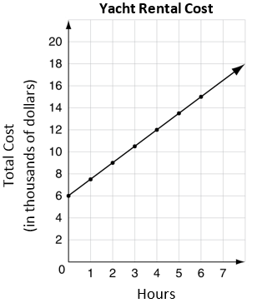
- A Pahokee yacht rental service charges its customers the same amount for each hour they rent a yacht, plus a monthly subscription fee. The graph below models the total monthly cost for using the service. Which of the following shows the hourly rental rate and subscription fee for the yacht rental service?
  - Hourly Rate: $1,500 per hour
Subscription Fee: $6,000
  - Hourly Rate: $1,500 per hour
Subscription Fee: $7,500
  - Hourly Rate: $6,000 per hour
Subscription Fee: $1,500
  - Hourly Rate: $6,000
Subscription Fee: $7,500

- The graph below shows the relationship between the number of hotdogs sold at a hotdog stand and the profit in dollars.
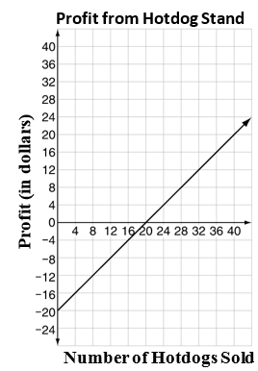
Which of the following best describes the y-intercept of the graph above?
  - the cost of supplies for the stand
  - the price of each hotdog
  - number of cups sold before the first hour
  - the amount earned after the first hotdog was sold

