Name: _______________________________________________________ Date: ___/___/___

1. Barbara bought a new mango tree and planted it in her back yard. She drew the table below to chart the growth of her new tree. Based on the table, at what rate is Barbara’s tree growing?

|  |  |
| --- | --- |
| **Time (Weeks)** | **Height (cm)** |
| 1 | 122.3 |
| 2 | 124.6 |
| 3 | 126.9 |
| 4 | 129.2 |
| 5 | 131.5 |
| 6 | 133.8 |

1. What is the slope of the linear model?
2. 5.0
3. 0.5
4. 3.0
5. 1.0
6. Anatoly graphed his store’s costs below. Which statement best describes the rate of change in Anatoly’s graph?  
     
   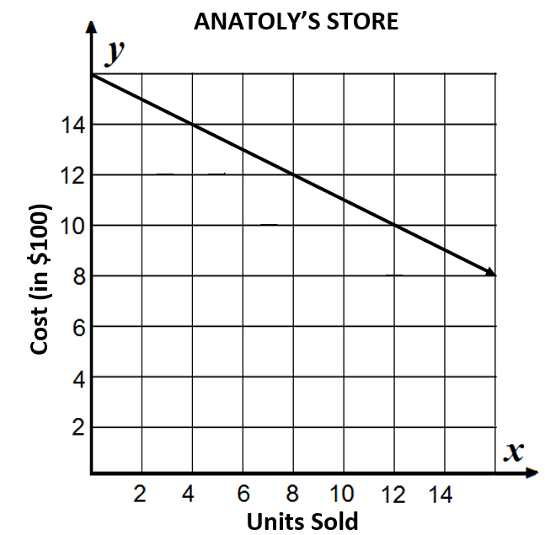  
   1. Anatoly cost decreased by $800.
   2. Anatoly’s business has a cost of $1,500.
   3. Anatoly’s costs decrease by $50 for every unit sold.
   4. Anatoly’s costs increase by $200 for every unit sold.
7. The table shows a linear model describing the change in depth of the Mississippi river in respect to the rainfall total for the month. What is the slope for this linear model?



1. 2.5
2. 4
3. 4.5
4. 5
5. What does the slope of a linear model represent?
6. The value of the x-intercept.
7. The value of the y-intercept.
8. The value of the independent variable when the dependent variable equals zero.
9. How quickly the dependent variable changes with respect to the independent variable.