Name: _______________________________________________________ Date: ___/___/___

1. Julio wants to make a small scale soccer field in his backyard for his daughter to practice. He has painted off lines to create a perimeter of 270 feet. He has also measured the length of the field to be 35 feet longer than the width of the field. Write and graph the system of equations which could be used to find the length and width of the field.

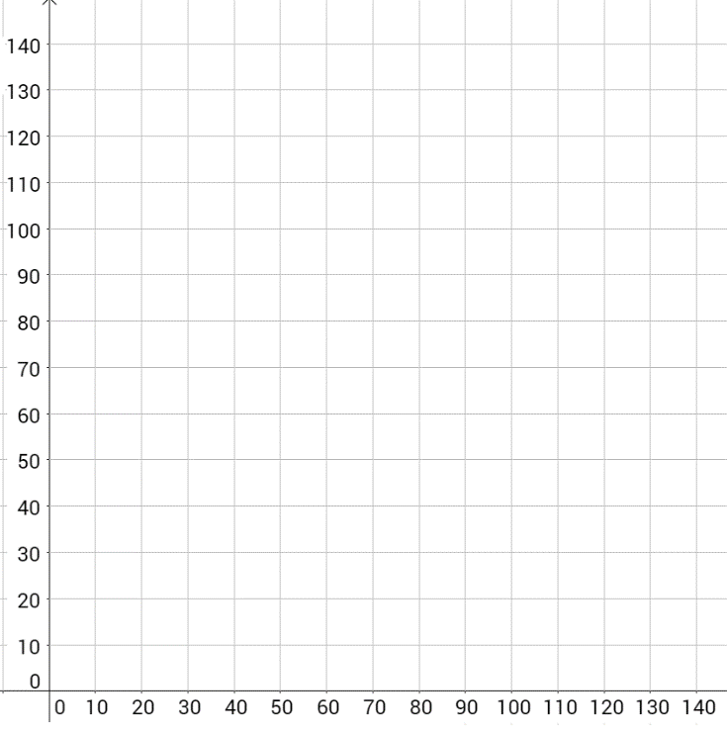

Length

Width

1. While analyzing the landing procedures of airplanes, George noted one plane at an altitude of 5,000 feet descending at a rate of 300 feet per minute and one at an altitude of 14,000 feet descending at a rate of 1,200 feet per minute. Which of the following solutions represents when the two airplanes will reach the same altitude?
   1. (6, 3200)
   2. (10, 2000)
   3. (12.7, 1190)
   4. (21, 1300)
2. Three times a number is subtracted from another number and the difference is 3. The sum of the two numbers is 31. What is the smaller of the two numbers?
3. Solve the system of equations below.



1. Solve the system of equations below.



|  |
| --- |
|  |