Name: _______________________________________________________ Date: ___/___/___
- Complete the function by entering values from the box below into the table.
2, 5, 10
x | y
1 | 2
2 | 5
3
2

- Which of the following statements accurately describes the mapping diagram below?
2
3
4
7

9
x y
  - This diagram is not a function because 7 is used twice.
  - This diagram is a function, since no domain values are repeated.
  - This diagram is not a function because there are too many domain values.
  - This diagram is not a function because there aren’t enough range values.

- Which of the relations below is not a function?
  - {(2, 7), (4, 13), (6, 19), (8, 25)}
  - {(5, 2), (7, 2), (9, 2), (11, 2)}
  - {(3, 1), (3, 4), (3, 9), (3, 16)}
  - {(-8, 8), (-7, 7), (-6, 6), (-5, 5)}

- Select all of the following that are functions.

A. {(2, 4);(4, 2); (3, 4); (4, 3)} |  | B. {(3, 13); (2, 12); (4, 14); (6, 16)}
C.  2  4  8  16  6  8  16  x  y |  | D.  14  18  26  2  3  5  7  x  y
E. 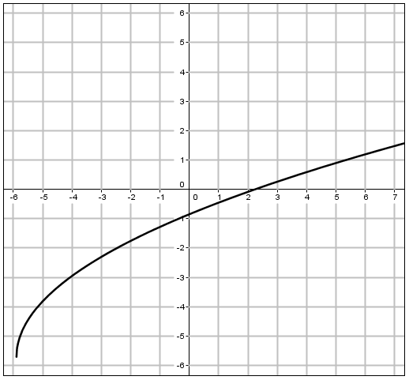 |  | F.  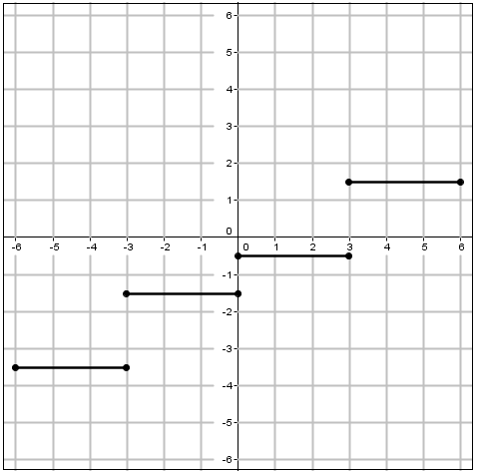

- After graphing the function below, Brenda noticed that one point was missing. Which of the following is the missing point in Brenda’s graph?
  - (0, 3)
  - (1, 2)
  - (2, -1)
  - (3, 2)

